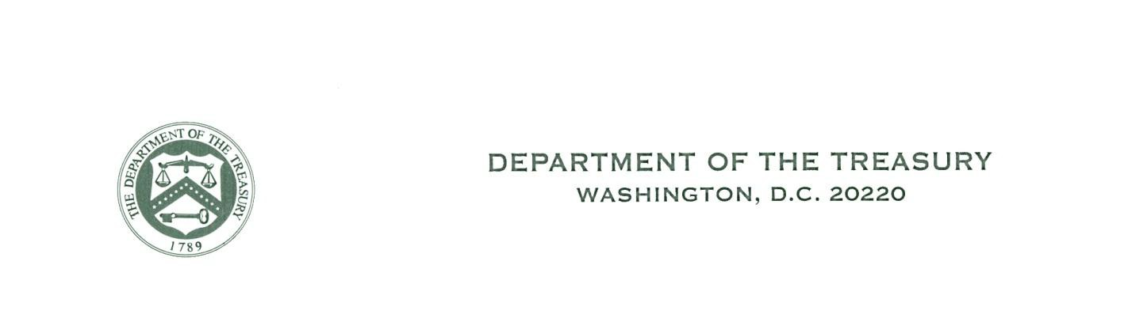
CT-2013-305326-2
Cuban Assets Control Regulations
License No.

A M E N D E D L I C E N S E

(Granted under the authority of 50 U.S.C. App. 5(b), 22 U.S.C. 2370(a), 22 U.S.C. 6001 et seq., Proclamation 3447, and 31 CFR Parts 501 and 515)

To: Environmental Adventure Company, LLC (the “Licensee”)
P.O. Box 1562 Livingston, MT 59047
Attn: Michael Sanders, President

- Pursuant to your application dated April 10, 2014 and with respect to License No. CT-2013-305326-1
(collectively, the “Application”) the following transactions are hereby licensed.

- This license is granted upon the statements and representations made in the Application, or otherwise filed with or made to the Treasury Department as a supplement to the Application, and is subject to the conditions, among others, that you comply in all respects with all regulations, rulings, orders, and instructions issued by the Secretary of the Treasury under the authority cited above and the terms of this license.

- The Licensee shall furnish and make available for inspection any relevant information, records or reports requested by the Secretary of the Treasury or any duly authorized officer or agency of the Secretary.

- This license is not transferable, is subject to the provisions of Title 31, Parts 501 and 515 of the Code of
Federal Regulations and any regulations and rulings issued pursuant thereto, and may be revoked or modified at any time at the discretion of the Secretary of the Treasury acting directly or through the agency through which the license was issued, or any other agency designated by the Secretary of the Treasury. If this license was issued as a result of willful misrepresentation on the part of the applicant or his duly authorized agent, it may, at the discretion of the Secretary of the Treasury, be declared void from the date of its issuance, or from any other date.

- This license does not excuse compliance with any law or regulation (including reporting requirements) administered by the Office of Foreign Assets Control (“OFAC”) or any other agency applicable to the transactions(s) herein licensed, nor does it release the Licensee or third parties from civil or criminal liability for violation of any law or regulation.

Issued on behalf of the Secretary of the Treasury:

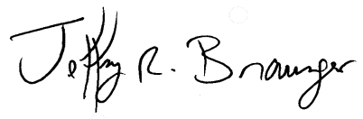
OFFICE OF FOREIGN ASSETS CONTROL

4/28/2014
By
Jeffrey R. Braunger Date Chief, Licensing Division

[Attention is directed to 18 U.S.C. 1001, 50 U.S.C App. 16, 31 CFR 501.701 et seq., and 31 CFR 515.701 et seq. for provisions relating to penalties.]

