Biology 101 Laboratory
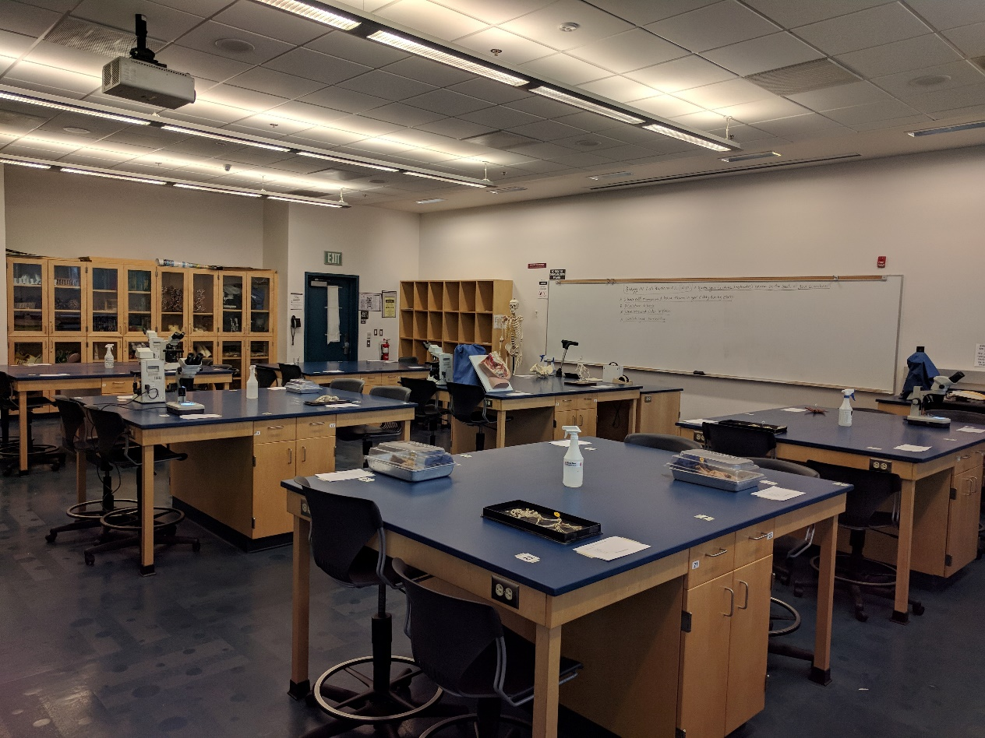
Biology 101 Lab Practicum #2 Set up

Sample Lab Practicum Questions
Lab Practicum #1 (specimens, slides, demonstrations)

1) (Amoeba) The primary means by which this organism obtains food is,
a) photosynthesis b) phagocytosis c) flagella d) absorption e) mitosis.

2) (Clonorchis sinensis) This organism is classified as a, a) flagellate b) turbellarian c) sporozoan d) nematode e) none of these.

3) (chiton) This organism is classified as a, a) arachnid b) diplopod c) bivalve d) polyplacophoran e) cephalopod.

4) (osmometer) The lower percentage of sugar in bag B, compared to bag A, should result in, a) higher osmotic pressure in bag B b) a faster influx of water into bag B c) a faster influx of water into bag A d) no significant difference in the movement of water in both bag A and B e) movement of water into the beaker instead of into bag A.

5) (Chlamydomonas) This organism obtains its nourishment primarily by, a) photosynthesis b) phagocytosis c) flagella d) pseudopodia e) intercellular digestion.

6) (Earthworm) This animal breathes by primarily using its, a) gills b) lungs c) skin d) mouth e) nose.

7) (crayfish) This animal is classified as a, a) isopod b) polyplod c) myriapod d) crustacean e) annelid.

Lab Practicum #2 (specimens, slides, demonstrations, concepts)

1) (dicot cross section slide) The primary function of the tissue indicated (phloem) is, a) transport of water b) transport of sugars c) photosynthesis d) evapotranspiration e) water uptake.
2) (muscle tissue slide) This tissue (smooth muscle) is found in the, a) skeletal system b) brain c) reproductive system d) digestive system e) c & d.
3) (pinned frog specimen) This organ (gall bladder) functions primarily for, a) storage and release of bile b) absorption of fat c) elimination of urine d) digestion of protein e) detoxification of alcohol.
4) (pinned sheep brain specimen) This part of the brain (cerebrum) functions primarily for, a) coordination and equilibrium b) temperature regulation c) regulation of breathing d) intelligence and memory e) diurnal/nocturnal activity patterns.
5) (test tube and Bromothymol blue) A positive color change test result with this substance indicates, a) the presence of sugar b) the presence of enzymes c) acidification due to the presence of carbon dioxide d) alkalinity due to the presence of oxygen e) the presence of protein.
6) (slide of rat testes) The process taking place in this tissue is known as, a) oogenesis b) spermatogenesis c) meiosis d) digestion e) b & c.
7) Giving type O Rh - blood to a recipient with type A Rh+ blood will probably result in,
a) a harmless mixing of blood types b) agglutination of the donor’s blood c) agglutination of the recipient’s blood d) a loss of the recipient’s blood e) a medical malpractice lawsuit.
8) (pinned heart specimen) This part of the heart (left atrium) normally receives blood from the, a) aorta b) superior vena cava c) right ventricle d) pulmonary veins e) pulmonary artery.

